Saint-Gobain Construction Products Rus LLC

Thermo-technical calculation
SP 50.13330.2012
“Thermal protection of buildings”

VIRMAK

2020
Initial data
Type of construction: Sandwich wall
Territory: Krasnodar Region, Krasnodar
t_{ext} Design external air temperature:  (reliability of 0.92, SP 131.13330.2012 t.3.1) | - 16 °C
t_{ht} Design average air temperature of heating season:  (with daily average temperature t ≤ 8°C, SP 131.13330.2012 t.3.1) | 2.5 °C
z_{ht} Duration of heating season:  (with daily average temperature t ≤ 8°C, SP 131.13330.2012 t.3.1) | 145 days
Humidity area | dry

Intended use of building and room
Building: residential unit
Room: habitable room
Coefficient a:  (SP 50.13330.2012, t.3) | 0.00035
Coefficient b:  (SP 50.13330.2012, t.3) | 1.4
a_{int} - Internal film heat-transfer coefficient:  (as per SP 50.13330.2012, t.4) | 8.7
Rate temperature drop between temperature of internal air and temperature of internal surface of enclosing structure:  (as per SP 50.13330.2012, t.5) | 4°C
a_{ext} - External film heat-transfer coefficient:  (as per SP 50.13330.2012, t.6) | 12
t_{int} Temperature of staying:  (as per GOST 30494-2011) | 20°C
ф - Relative humidity:  (as per GOST 30494-2011, SP 131.13330.2012, t.3.1) | no more than 60%
Moist room conditions:  (SP 50.13330.2012, t.1) | regular
Enclosing structures operation practices:  (SP 50.13330.2012, t.2) | A
Coefficient of structure uniformity r:  (as per GOST R 54851-2011) | 0.8
Dependency ratio of enclosing structure position n:  (SP 50.13330.2012, f.5.3) | 1

Saint-Gobain Construction Products Rus LLC
140300, Moscow Region, Egorievsk, Smychka Street, bld. 60
Phone: +7 (495) 775 1512, Fax: +7 (495) 775 1513
E-mail: isover@saint-gobain.com, http://www.isover.ru

Makeup of structure
No. | Layer | Thickness, mm | Note
1 | Сement bonded particleboard | 12 | λ = 58 W/(m °C)
2 | Thermal insulating layer  ISOVER Sandwich LIFE | 110 | λ = 0.04 W/(m °C)  μ = 0.3 mg/ m·h·Pa
3 | Сement bonded particleboard | 12 | λ = 58 W/(m °C)

Heating season degree-day (HSDD):
(SP. 50.13330.2012 f.5.2)
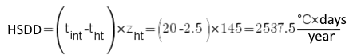

Normalized heat transfer resistance:
(SP 50.13330.2012)
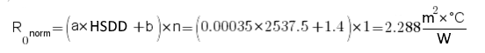
Calculation of heat transfer resistance

CBPB, homogeneous layer, δ=12 mm, λ =58 W/(m °С)

Heat transfer resistance:

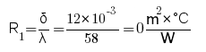
CBPB, homogeneous layer, δ=12 mm, λ =58 W/(m °С)

Heat transfer resistance:
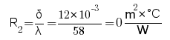
Calculation of an approximate heat transfer resistance of insulant
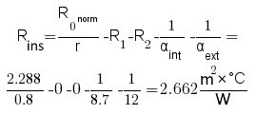
Calculation of an approximate thickness of insulant layer from condition:
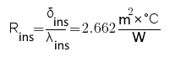
where λ_{ins} = 0.04 W/(m °C)

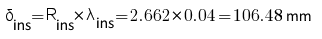
Saint-Gobain Construction Products Rus LLC
140300, Moscow Region, Egorievsk, Smychka Street, bld. 60
Phone: +7 (495) 775 1512, Fax: +7 (495) 775 1513
E-mail: isover@saint-gobain.com, http://www.isover.ru
Due to the multiplicity of materials, the thickness of thermal insulating layer is taken to be equal to δ_{thick} = 110 mm. Then the reduced total thermal resistance:
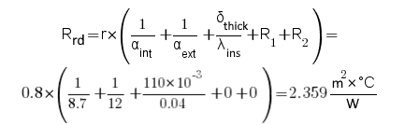
The condition R_{0norm}≤R_{rd} is fulfilled: 2.288 ≤ 2.359.

Sanitary requirements

Calculation of temperature drop between temperature of internal air and temperature of internal surface of enclosing structure:
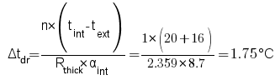
The condition Δt_{rated} ≥ Δt_{dr} is fulfilled: 4≥1.75

The temperature of internal surface – Ti, °С of enclosing structure (not including heat-conducting factor) shall be calculated according to the formula:
The condition Тi ≥ t_{cond} is fulfilled : 18.25 ≥ 12
where t_{cond} stands for condensing point temperature.

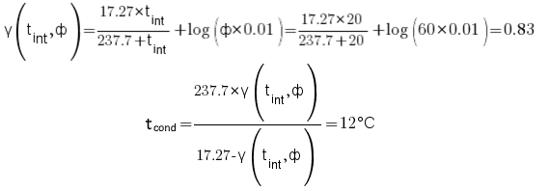

Heating pattern in structural section

The temperature t_{x}, °С of enclosing structure in plane corresponding to the layer x boundary, shall be calculated according to the formula:
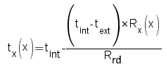
Saint-Gobain Construction Products Rus LLC
140300, Moscow Region, Egorievsk, Smychka Street, bld. 60
Phone: +7 (495) 775 1512, Fax: +7 (495) 775 1513
E-mail: isover@saint-gobain.com, http://www.isover.ru
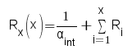
where x stands for the number of layer, x=0 stands for the internal space, R_{i} stands for heat transfer resistance of layer with number I, in the direction from internal space.

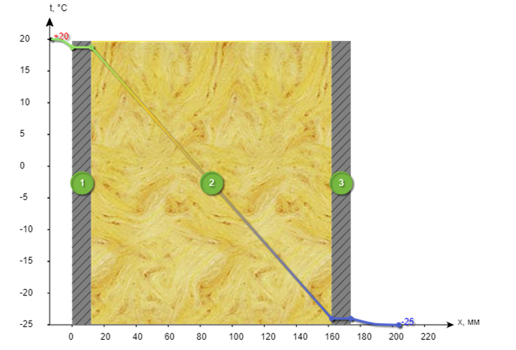
Point 1: t_{int} = 20°С – temperature inside the room
Point 2: t_{x}(0) = 18.66°С – temperature at the internal boundary of layer No.1 – “CBPB”
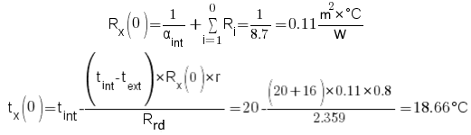
Point 3: t_{x}(1) = 18.66°С – temperature at boundary of layer No.1 “CBPB” and layer No.2 ISOVER Sandwich Life
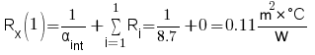

Saint-Gobain Construction Products Rus LLC
140300, Moscow Region, Egorievsk, Smychka Street, bld. 60
Phone: +7 (495) 775 1512, Fax: +7 (495) 775 1513
E-mail: isover@saint-gobain.com, http://www.isover.ru

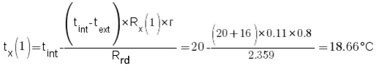
Point 4: t_{x}(2) = -14.92°С – temperature at boundary of layer No.2 ISOVER Sandwich Life and layer No.3 “CBPB”
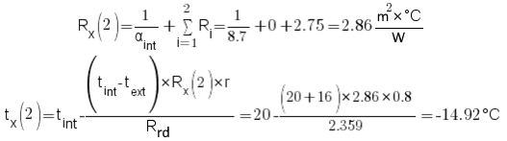
Point 5: t_{x}(3) = -14.92°С – temperature at the outside boundary of layer No. 3 - “CBPB”
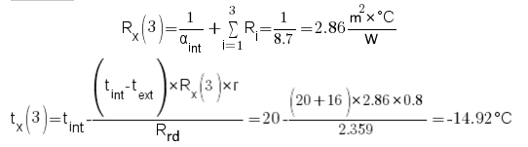
Point 6: t_{ext} = -16°С - outside temperature
Determination of the plane of a maximum moistening (condensation)
This is a calculation procedure based on the use of method of dimensionless characteristics.
The value of f_{i} (t_{max.m.),} an indicative of the temperature in the plane of maximum moistening, shall be calculated for each layer of multilayer structure.
No. of layer | Layer of structure | Rni=δi/μi | μi/λi
Internal surface of enclosing structure |  | Rint,vp = 0.0266 | 0
1 | CBPB | 0 | 0
2 | ISOVER Sandwich Life | 0.11 / 0.3 = 0.367 | 0.3 / 0.04 = 7.5
3 | CBPB | 0 | 0
Outside surface of enclosing structure |  | Rext,vp = 0.0133 | 0
Rint,vp and Rext,vp – resistance to moisture exchange respectively of internal and outside surfaces of enclosing structure, (m2·h·Pa / mg).
Note:
1. Resistance to vapour permeability of close air spaces in enclosing structures shall be taken as equal to zero regardless the position and thickness of these spaces.
2. Layers of structure, located between an air space, ventilated with outside air, and outside surface of enclosing structure shall not be taken into calculation.

Saint-Gobain Construction Products Rus LLC
140300, Moscow Region, Egorievsk, Smychka Street, bld. 60
Phone: +7 (495) 775 1512, Fax: +7 (495) 775 1513
E-mail: isover@saint-gobain.com, http://www.isover.ru

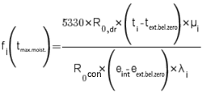
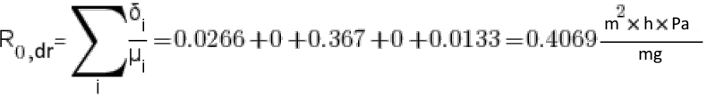

E_{sat} - partial pressure of saturated steam, Pa, at the air temperature from -40 to + 45 °C is determined according to the formula:
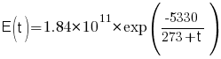
For the temperature t_{sat} = 20 °C:
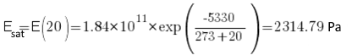
e_{int} - partial pressure of saturated steam of internal air, Pa, at the designed temperature and relative humidity in room is determined according to the formula:
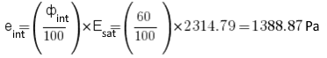
e_{ext.bel.zero} - partial pressure of saturated steam of external air for the period of months with below zero monthly average temperature is determined according to SP 131.13330:
e_{ext.bel.zero} = 100 x 4.9 = 490 Pa
t_{ext.bel.zero} – average temperature of external air for the period of months with below zero monthly average temperature is determined according to SP 131.13330:
t_{ext.bel.zero} = -0.2 = -0.2 °C
μi/λi – the ratio of heat-transfer coefficients, W/(m2 x °C ), and steam permeability, mg/(m x h x Pa), of material of corresponding layer, or 0 if the coefficients are not set.
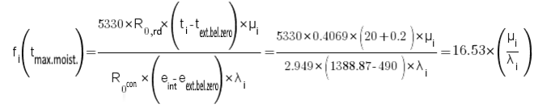
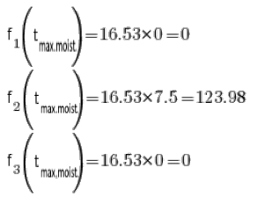
According to SP 50.13330 table 11, when f_{i}(t_{max.moist}) is not negative, than t_{max.moist} can be calculated according to formula:
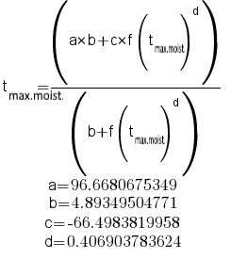
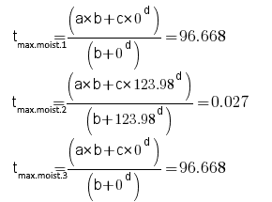
Calculation of temperature at boundaries of layers
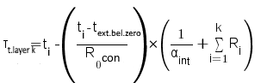
where R_{i} – heat transfer resistance of the layer I (or 0 if this layer is not included in thermo-technical calculation), k – number of layer for which the temperature is calculated.
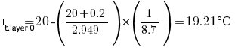
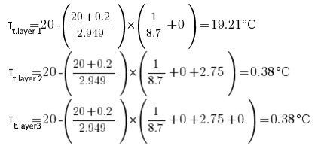
Summary table t_{max.moist.} and τ_{t.layer k}
This is the table that includes the value of t_{max.moist.} for each layer and temperatures at boundaries of layers (at average temperature of external air in a period of below zero monthly average temperatures):
No. of layer | Layer of the structure | Τt.layer k, °C | tmax.moist., °C
0 | CBPB | 19.21 | 96.668
1 |  | 19.21
1 | ISOVER Sandwich Life | 19.21 | 0.027
2 |  | 0.38
2 | CBPB | 0.38 | 96.668
3 |  | 0.38

Determination of the maximum moistening plane
As you can see in the table, there is not a single layer with a temperature of t max. moist. within the limits ofτt.layer. Also, there are no pairs of adjacent layers where the condition t max. moist. > max(τt.layer) for the colder layer and the condition t max. moist. > max(τt.layer) for the warmer layer are satisfied.
In this case, the plane of maximum moistening is taken on the external surface of the structure. Protection from excessive moistening is not required.
The structural components does not require additional measures to protect against excessive moistening.

Conclusion

The structure is designed to meet the requirements of SP 50.13330.2012 "Thermal protection of buildings" and SP 131.13330.2012 "Construction Climatology".
The thickness of the thermal insulation layer of ISOVER Sandwich Life is 110 mm. According to the calculation:
- The structural components meet the requirements for thermal protection.
- The structural components meet the sanitary and hygienic requirements.
- The structural components does not require additional measures to protect against excessive moistening.

Where to buy

Saturn-Krasnodar JSC  Address: Krasnodar, Krasnodar, Uralskaya St., bld. 128 | Phone: +7 (861) 212-66-00  Website: http://krd.saturn.net
GK Sibirskiy Biznes  Address: Krasnodar, Krasnodar, Ippodromnaya Str. 1/1 | Phone: +7 (861) 210-04-10  Website: http://www.sbiznes.ru
GK Sibirskiy Biznes  Address: Krasnodar, Krasnodar, Ippodromnaya Str. 1/1 | Phone: +7 (861) 210-08-87  Website: http://www.sbiznes.ru
ALEA LLC  Address: Krasnodar, Krasnodar, Novorossiyskaya Str. bld. 236 | Phone: 8-800-200-26-59  Website: https://krd.aleacompany.ru/
GrandLine-Center LLC  Address: Krasnodar, Krasnodar, Dzerzhinsky Str, bld. 112 | Phone: +7 (861) 258-33-87  Website: http://yugmontag.ru
METAL PROFILE Company LLC  Address: Krasnodar, Krasnodar, Garazhnaya Str., bld. 91 | Phone: +7 (861) 253-53-70  Website: http://metallprofil.ru
Contrast LLC  Address: Krasnodar, Krasnodar, Dimitrova Str., bld. 11/3 | Phone: +7 (861) 212-30-25  Website: http://krdregion.ru
MIA Construction LLC  Address: Krasnodar, Krasnodar, Kommunarov Str., 268, A, office 80 | Phone: +7 (918) 368-82-18
Opt dlya Optovikov LLC  Address: Krasnodar, Krasnodar, Dalnaya Str., bld 43, office 404 | Phone: +7 (861) 225-28-08  Website: http://barta.su
PORT LLC  Address: Krasnodar, Krasnodar, Aeroportovsky ave. bld.8 | Phone: +7 (928) 257-28-98  Website: http://opt-port.ru
SpetsTorg-Krasnodar LLC  Address: Krasnodar, Krasnodar, Uralskaya Ыtr., 144, 3rd floor, office 313, 303 | Phone: +7 (861) 203-00-23  Website: http://idalgo.su
TPC Edelweiss LLC  Address: Krasnodar, Krasnodar, Severskiy district, urban-type settlement Afipsky, Smolenskoye shosse, bld. 8 | Phone: +7 (861) 279-01-00  Website: http://eweiss.ru
PKF Everest LLC  Address: Krasnodar, Krasnodar, Stasova Str., bld.178-180/1 | Phone: +7 (861) 299 62 71  Website: http://everest-grupp.ru
METAL PROFILE Company LLC  Address: Krasnodar, Krasnodar, Dinskaya village, Kraynaya Str., 14 | Phone: +7 (861) 625-51-51  Website: http://metallprofil.ru
ALEA LLC  Address: Krasnodar, Sochi, Mira Str., bld 25 | Phone: +7 (862) 240-48-13  Website: http://aleacompany.ru
StavropolStroyIndustriya LLC  Address: Krasnodar, Sochi, Olympiysky ave., 1 | Phone: +7 (862) 260 82-39  Website: http://td-stroybaza.ru
Krovelny pirog LLC  Address:Krasnodar, Novorossiysk, Lenina Str, 6B, Tsemdolina village | Phone: 8 800 707 86-17  Website: http://roofpirog.ru
Saturn-Krasnodar JSC  Address: Krasnodar, Krasnodar, Uralskaya St., bld. 128 | Phone: +7 (861) 212-66-00  Website: http://krd.saturn.net
Teplostroy LLC  Address: Krasnodar, Krasnoyarsk, Kalinina Str., 73A | Phone: +7 (391) 268-30-82  Website: https://vsemktostroit.ru/ catalog/uteplitel-na-osnove-kvartsa/
PORT LLC  Address: Krasnodar, Yeisk, Michurina Str., 12/12 | Phone: +7 (928) 846-58-48  Website: http://opt-port.ru
IE Verkhoturov A.Yu.  Address: Krasnodar, Anapa, Anapskoe Shosse, bld. 1 | Phone: +7 (861) 334-55-55  Website: http://td-piramida.ru

For purchasing materials, please contact

Alexey Voloshchuk
Sales Manager

LLC Saint-Gobain Construction Products Rus
Mobile: 89181887676
E-mail: Alexey.Voloshuk@saint-gobain.com
www.saint-gobain.ru

